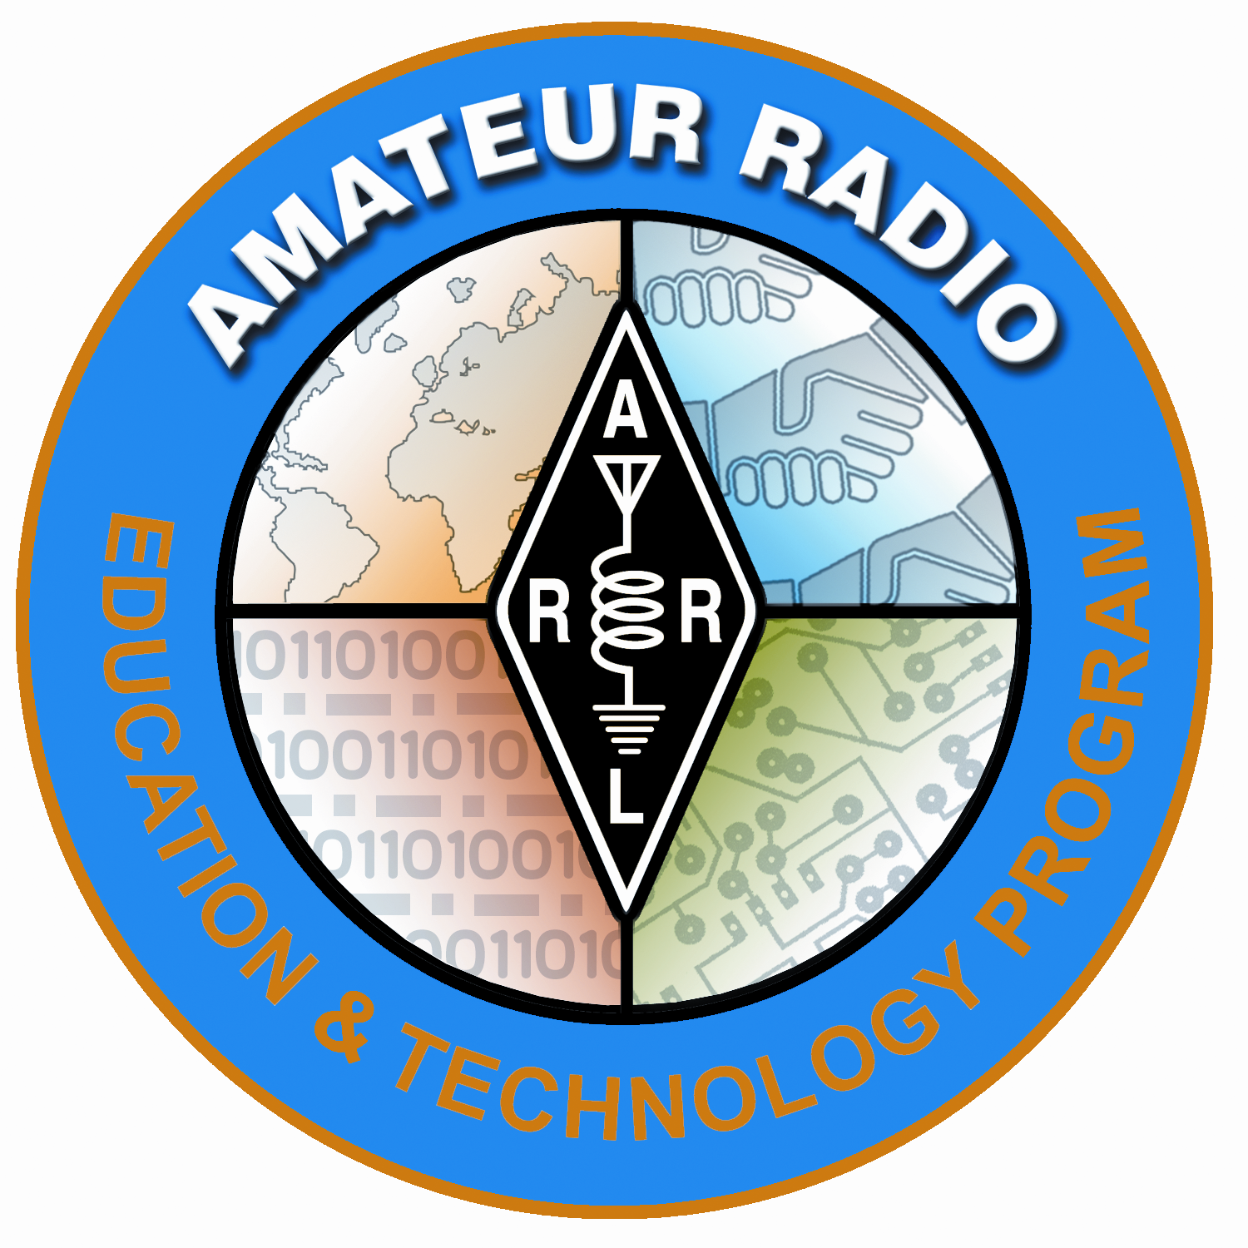
Lesson Plan Prepared for
ARRL Education & Technology Program
Author(s): Nathan McCray | Date: 05/21/2013
Title of Lesson: Kepler’s 2nd Law (The law of equal areas) | Grade Level: 4 – 12

Core Components

Subject, Content Area or Topic:

Physics, Electronics, Science, Math

National/State Standards: (Assign as needed based on your state standards)

Common Core Standards: (Assign as needed based on your state requirements)

http://www.corestandards.org/

Vocabulary: (Teacher add as needed based on your curriculum and learning requirements)

Learning Objectives (What will the students learn and/or demonstrate?)

The objective of this activity is for the students to explore Kepler’s 2nd Law

Materials/Resources
Cardboard, paper, two straight pins, ruler and pencil.

Safety (if applicable) NA

Prerequisite Understanding:

Process Components
Anticipatory Set:
(“The Hook” -- something to excite the student about the subject matter)
“A line joining a planet and the Sun sweeps out equal areas during equal intervals of time."

Ask:

Instructional Input or Procedure (Input, modeling, and checking for understanding)

Activity:
- An ellipse is shaped like a circle but one end is longer than the other.
- Foci are two points inside the ellipse.
- Using a magnetic white board or something like it, stick a magnet onto the foci and put a loop of string around them.
- Draw an ellipse
- Measure the Ellipse at AB (Major Axis) and CD (minor axis). Are they the same measurement? Why or why not?

From this activity we have learned that the object being orbited sits at one focus, and the other object follows the path of the ellipse.
- The sketch of the Earth orbiting the Sun should look like this…

Guided Practice

Optional lesson:

Materials: Cardboard, paper, two straight pins, ruler and pencil

Procedure:

- Place the piece of paper on top of the cardboard
- Stick the two pins on the paper (Push into cardboard so it sticks well)
- Tie a loop of string that is 12 cm long and then place the loop of string around the two pins.
- Place the point of your pencil inside the loop and pull it so it is tight. Draw a line keeping the string tight at all times.
- What shape did you just draw?
- Does this confirm Kepler’s 1st law? Why or why not?
- How would you define the pins in this lab?

Independent Practice

Draw 3 ellipses using the following dimensions:

Ellipse 1 – Distance between pin 10 cm
Ellipse 2 – Distance between pin 5 cm
Ellipse 3 – Distance between pin 2.5 cm

Assessment/Closure

Assessment (Pre, post etc…)

As teacher sees fit.
Enrichment: As teacher sees fit.
Resources/References

http://highered.mcgraw-hill.com/olcweb/cgi/pluginpop.cgi?it=swf::800::600::/sites/dl/free/0072509856/78778/Kepler_Nav.swf::Keplers%20Second%20Law%20Interactive

http://astro.unl.edu/classaction/animations/renaissance/kepler.html

*Every lesson is different so you may not have to fill in all areas.

Notes: Random trivia….or enrichment…
Tale of 2 Moons: Io and Earth's Moon
Amazing enough, Jupiter's moon Io and the Earth's Moon are roughly the same distance from their parent planets. Io's mean distance from Jupiter is 262,000 miles, and the Moon's mean distance from Earth is 239,000 miles.
Why does Io revolve around Jupiter in only 1.769 days, while the Moon takes a whopping 27.322 days to revolve around the Earth? Shouldn't the orbital periods of both moons be similar since the distances of the two moons from their parent planets are similar? If anything, shouldn't Io's orbital period be a bit longer since Io is farther out from the center its parent planet?
The answer would be yes in both instances, if both Earth and Jupiter had the same mass (weight). However, Jupiter has 318 times the Earth's mass. Or another way of putting it: Earth has 1/318 Jupiter's mass. The more massive the planet, the faster the moon's orbital period. The less massive the planet, the slower the moon's orbital period.

If the Earth's Mass Equaled that of Jupiter, What Would the Moon's Orbital Period Be?
To find out what the Moon's orbital period would be if the Earth equaled Jupiter in mass (318 Earth-masses), take the Moon's orbital period (27.322 days) and divide it by the square root of Jupiter's mass (the square root of 318 = 17.83).
27.322 days divided by 17.83 = 1.53 days
And to find out what Io's orbital period would be if Jupiter equaled Earth's mass (1/318), take Io's orbital period (1.769 days) and divide it by the square root of 1/318. The square root of 1/318 = 1/17.83 = 0.056.
1.769 days divided by 0.056 = 31.55 days

