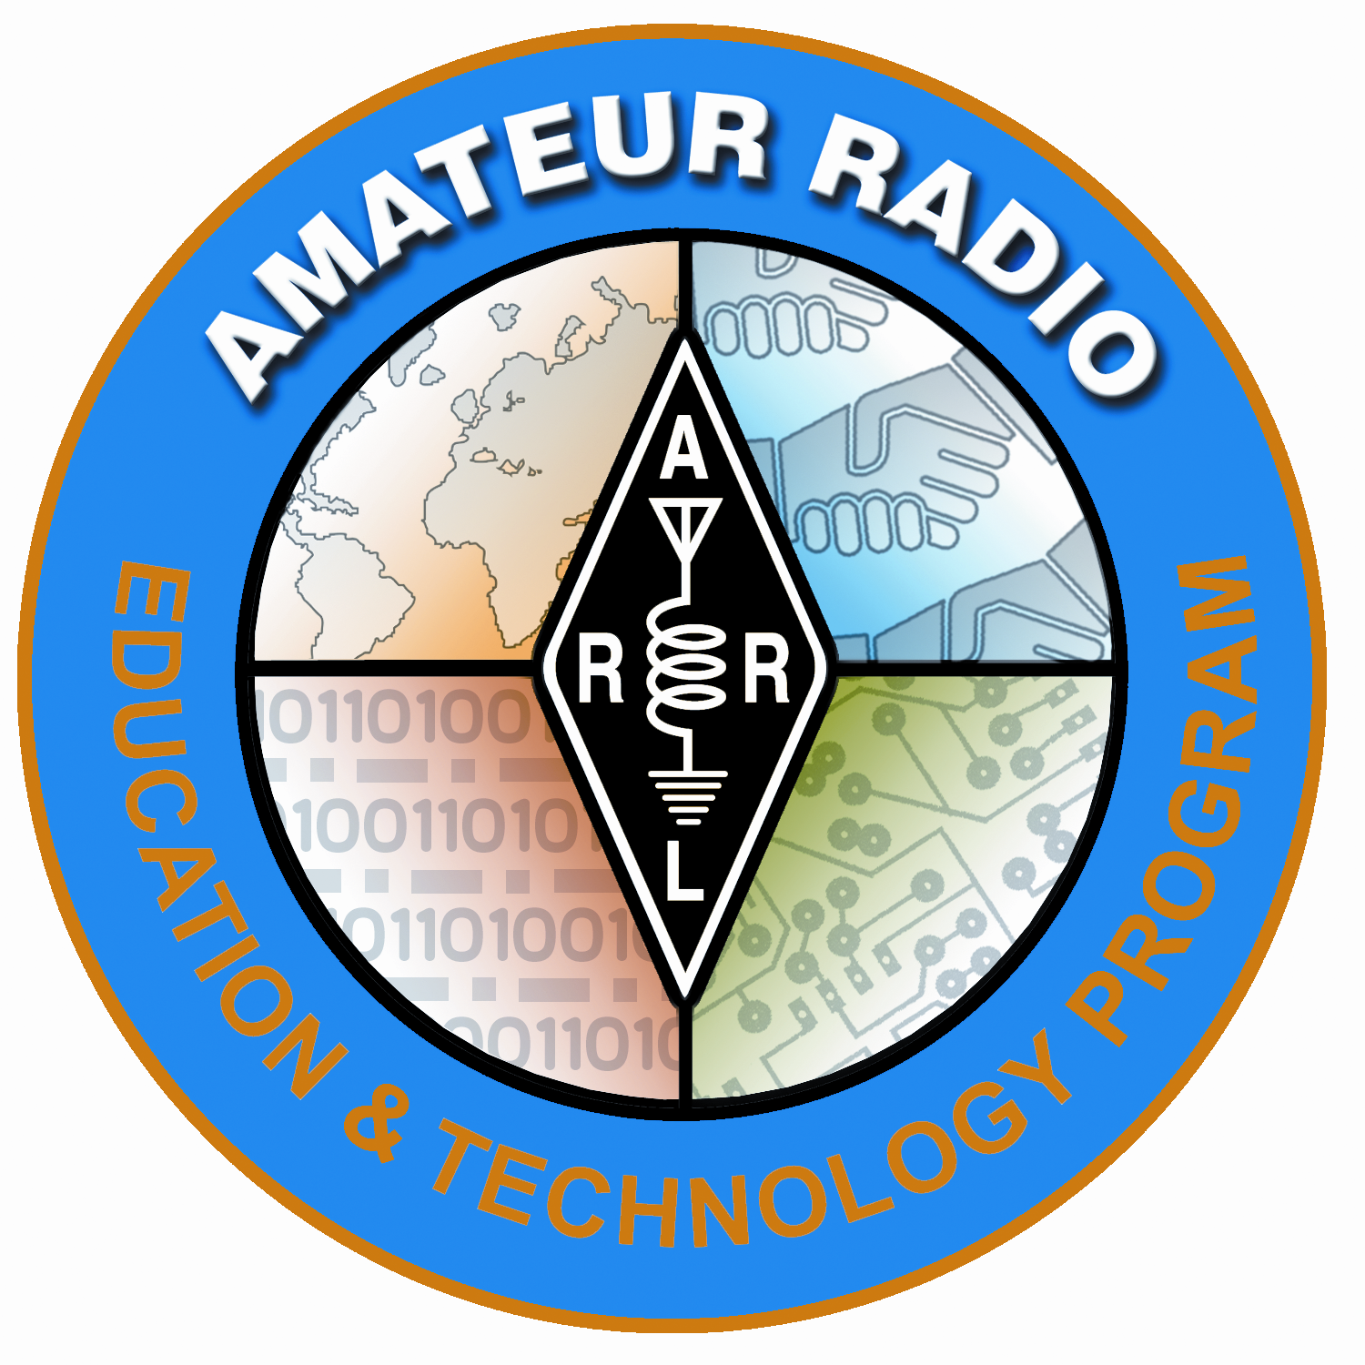
Lesson Plan Prepared for
ARRL Education & Technology Program
Author(s): Nathan McCray | Date: 05/10/2013
Title of Lesson: Kepler’s 1st Law | Grade Level: 4 – 12

Core Components

Subject, Content Area or Topic:

Physics, Electronics, Science, Math

National/State Standards: (Assign as needed based on your state standards)

Common Core Standards: (Assign as needed based on your state requirements)

http://www.corestandards.org/

Vocabulary: (Teacher add as needed based on your curriculum and learning requirements)

Learning Objectives (What will the students learn and/or demonstrate?)

The objective of this activity is for the students to explore Kepler’s 1st Law

Materials/Resources

Safety (if applicable) NA

Prerequisite Understanding:

Process Components
Anticipatory Set:
(“The Hook” -- something to excite the student about the subject matter)
“The path of any object in an orbit follows the shape of an ellipse,
with the orbited body at one of the foci.”

Ask:
- How would you draw the Earth’s orbit around the sun? Go ahead and draw it.
- Did you draw the sun in the center of a circle?
- Do you think our orbit is a perfect circle?
Instructional Input or Procedure (Input, modeling, and checking for understanding)
C
Ellipse

Foci

B
A

D
Activity:
- An ellipse is shaped like a circle but one end is longer than the other.
- Foci are two points inside the ellipse.
- Using a magnetic white board or something like it, stick a magnet onto the foci and put a loop of string around them.
- Draw an ellipse
- Measure the Ellipse at AB (Major Axis) and CD (minor axis). Are they the same measurement? Why or why not?

From this activity we have learned that the object being orbited sits at one focus, and the other object follows the path of the ellipse.
- The sketch of the Earth orbiting the Sun should look like this…

Guided Practice

Optional lesson:

Materials: Cardboard, paper, two straight pins, ruler and pencil

Procedure:

- Place the piece of paper on top of the cardboard
- Stick the two pins on the paper (Push into cardboard so it sticks well)
- Tie a loop of string that is 12 cm long and then place the loop of string around the two pins.
- Place the point of your pencil inside the loop and pull it so it is tight. Draw a line keeping the string tight at all times.
- What shape did you just draw?
- Does this confirm Kepler’s 1st law? Why or why not?
- How would you define the pins in this lab?

Independent Practice

Draw 3 ellipses using the following dimensions:

Ellipse 1 – Distance between pin 10 cm
Ellipse 2 – Distance between pin 5 cm
Ellipse 3 – Distance between pin 2.5 cm

Assessment/Closure

Assessment (Pre, post etc…)

Enrichment: As teacher sees fit.
Resources/References

http://www.windows2universe.org/the_universe/uts/kepler1.html

http://www-pvhs.stjohns.k12.fl.us/teachers/veatchd/12F00792-0118C716.43/Kepler%27s%20Laws%20lab.pdf

*Every lesson is different so you may not have to fill in all areas.

Notes:

