
Lesson Plan Prepared for
ARRL Education & Technology Program
Author(s): Nathan McCray | Date: 02/15/2013
Title of Lesson: Resistors | Grade Level: 4 – 12

Core Components

Subject, Content Area or Topic:

Physics, Electronics, Science, Math

National/State Standards: (Assign as needed based on your state standards)

Common Core Standards: (Assign as needed based on your state requirements)

http://www.corestandards.org/

Vocabulary: (Teacher add as needed based on your curriculum and learning requirements)

Learning Objectives (What will the students learn and/or demonstrate?)

The objective of this activity is for the students to explore resistors.

Materials/Resources

- Graphing paper
- Lead pencil
- 9 volt battery
- Leads (Preferably with alligator clips)
- LED (Red would be a cool color to use)
- Volt/Ohm Meter

Safety (if applicable) NA
- Talk about how fuses operate and the cautions surrounding replacing fuses (use the same current rated fuse as the one blown). .

- With no resistance in the circuit, the voltage source will provide the full current available to the circuit. There is essentially no resistance in the VOM probe lines, therefore if the probes are connected directly across the battery poles, the full current in the battery will flow through the VOM, and probably blow the fuses.
- Emphasize that during the current measurement exercises, they must be careful to ensure that the suggested resistance is in the circuit and that the VOM probes are placed as illustrated or shown.
- Have the class practice probe placement before connecting to power.

Prerequisite Understanding:
- Conductors and Insulators
- Basic Electricity
- Current
- Ohm’s Law

Process Components
Anticipatory Set:
(“The Hook” -- something to excite the student about the subject matter)

For this activity you and your students will need:

- Graphing paper
- Lead pencil
- 9 volt battery
- Leads (Preferably with alligator clips)
- LED (Red would be a cool color to use)
- Volt/Ohm Meter
*Note, you may demo this first, then have your students do this. Or, if you feel comfortable, have your students conduct the experiment with you at the same time. .

Directions:

- Fill in about a two inch area of single blocks on your graph paper with the led pencil. Apply it as heavy as you can! You are making a graphite resistor!
- Place one lead of your VOM on one side of the graphite resistor you made and the other lead on the other side. You should get a reading of about .5 Ohms.
- Move the leads closer together and you will see the meter change. You now have the equivalent of a variable resistor.
- Next, place the wire lead (with alligator clip) to the positive side of the 9V battery and the other end to the positive side of the red LED.
- Place the other wire on the negative side of the battery and then the other end to one side of the graphite resistor.
- Next, place the negative lead of the red LED to the graphite resistor.
- Move the wire that is on one end of the graphite resistor towards the red LED. You should see the LED get brighter as you move the wire closer to the LED and lighter as you move away (You made a dimmer!)

Questions:

- What would happen if you touched the wire lead directly to the red LED?

Talk with your students about what they are observing.

Instructional Input or Procedure (Input, modeling, and checking for understanding)

Preparation:

- Review with the students the properties of AC current.

- Review with the students the vocabulary needed to describe resistance. Then, go over the definition of resistance in a circuit.

- Review the anticipatory set and ensure they understand the concepts presented.

Start with some simple current measurements.

Go over with your audience the orientation of the different interconnected holes in the board. You may have a different board than the proto board. Ensure you are familiar with the board and demonstrate how your board works.
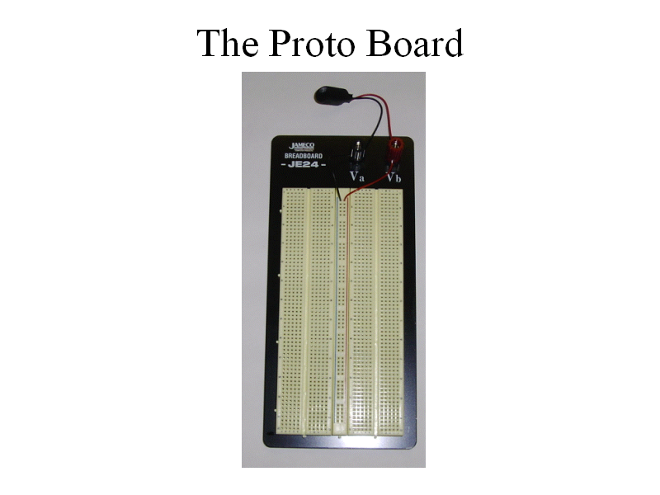
There are 4 banks of horizontal holes.

Point out the current flow path. It goes from the negative pole of the battery, through the resistor (which restricts the amount of current flow), then through the VOM, and finally returns to the battery positive pole. The VOM is part of the circuit.

Next, set up the first simple circuit:

Now connect up the battery and measure the current. Your readings will vary.

Next, replace the 100 ohm resistor with a 1k ohm resistor. Point out to the audience that the letter k here means kilo or 1000. The 1k resistor is 1000 ohms. 10k is 10,000 ohms, and 100k is 100,000 ohms.

What do you think will happen to the current flow through this higher resistance component? Their answer should be less current will flow.

Note. You may have a different board or set up. That is OK, just make sure to start with a simple circuit and move on from there.

Guided Practice

Resistance Measurements:

Now that your students have a basic understanding of the proto board (or bread board) and can measure current, it is now time to measure resistance.

When measuring resistance, there is a small voltage supplied by the meter to energize the component, the red probe lead has the positive voltage. The VOM then measures the current flowing through the component and the resistance is calculated using Ohm’s Law (which will be covered later in detail).

Go through the 5 ranges:
200 will read up to 200 ohms
2000 will read up to 2000 ohms
20K will read up to 20,000 ohms
200k will read up to 200,000 ohms
2000k will read up to 2,000,000 ohms or 2 meg ohms (meg means 1,000,000)

Place a 100 ohm resistor on the board. No power is required!

The resistor is put into the proto board only to hold the component.

Place one probe at each resister lead.
It does not matter which way the meter probes are placed on the resistor, the readings should be identical.
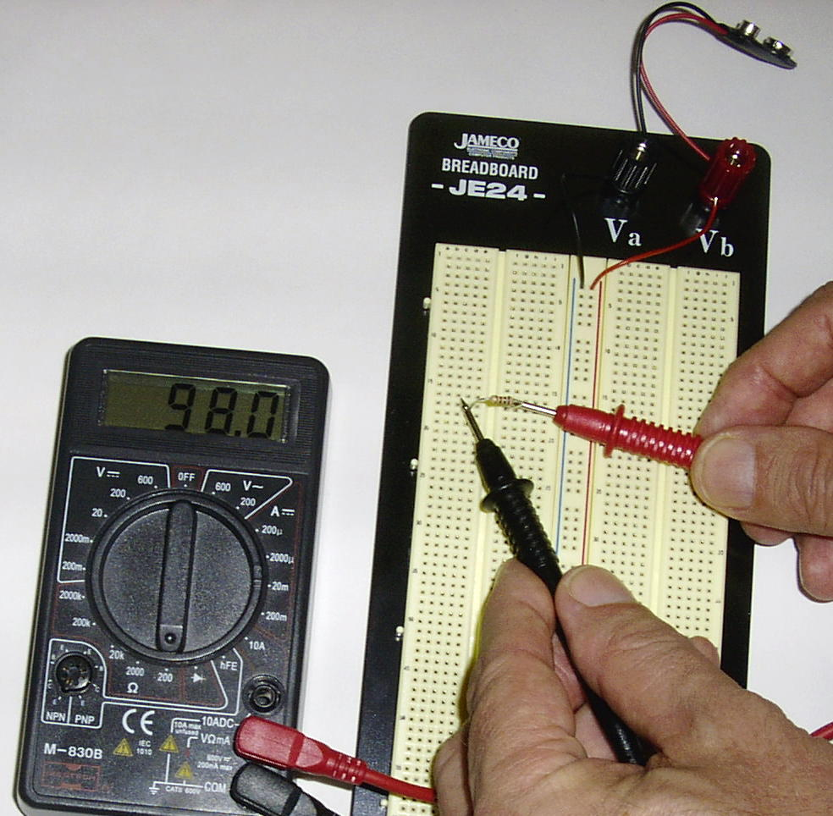
Your reading should look about the same as pictured. (It is always more meaningful to have the instructor demo this as the lesson goes on.)
Continue to measure the resistance of different resistors. When the times come you can begin building simple circuits and then move on to more complex circuits! (That would be another lesson.)

Independent Practice

Suggest some measurements the audience might make, but leave the majority of the measurement techniques up to them.

Some suggestions:
- Probes across individual fingers. 1.8 meg
- Probes held between thumb and finger, one in each hand. 1.4 meg
- Probes from the skin on the ankle and skin on hand. Off scale
- Dry skin versus moist skin. Dry 1 meg, moist 96k
- Lightly touching ht probes compared to a firmer grasp on the probes. Light 1 meg, firm 300k

The lesson here is that body contact with the probes during measurements can influence the ohmmeter reading and should be avoided, particularly when measuring high values of resistance.

Assessment/Closure

Assessment (Pre, post etc…)

What is resistance?

What is the purpose of a resistor in a circuit? Is there more than one purpose?

If you take a resistor out of its circuit and then apply power to that circuit, what may happen?

Enrichment:
Verify Ohms Law:
Measured Battery Voltage:_______
Measured Current:_____________
Measured Resistance: __________

E = I * R
_______=________*________

Resources/References

http://www.arrl.org/files/file/ETP/Basic%20Electronics%20Course.pdf

ARRL Handbook Pages 2.5 – 2.6

Understanding Basic Electronics pages 7.6 – 7.8

http://www.youtube.com/watch?v=VPVoY1QROMg

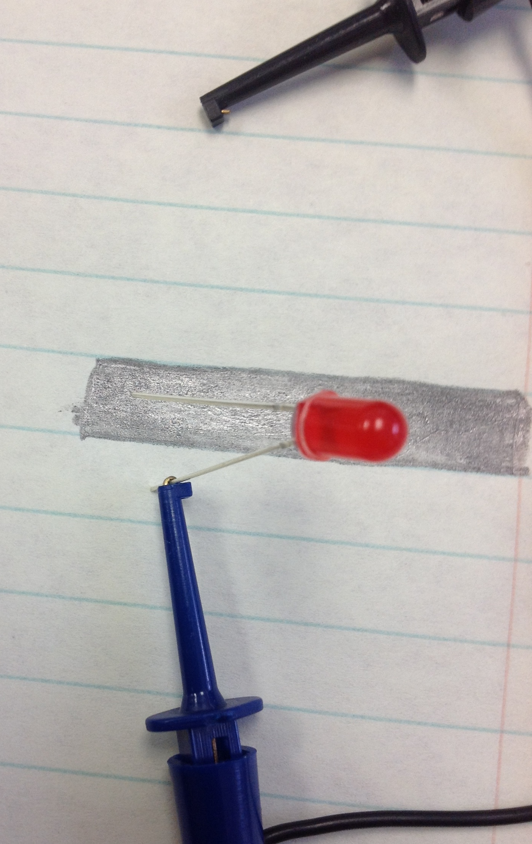
Positive (+) lead to long Lead on LED

*Every lesson is different so you may not have to fill in all areas.

Notes:

