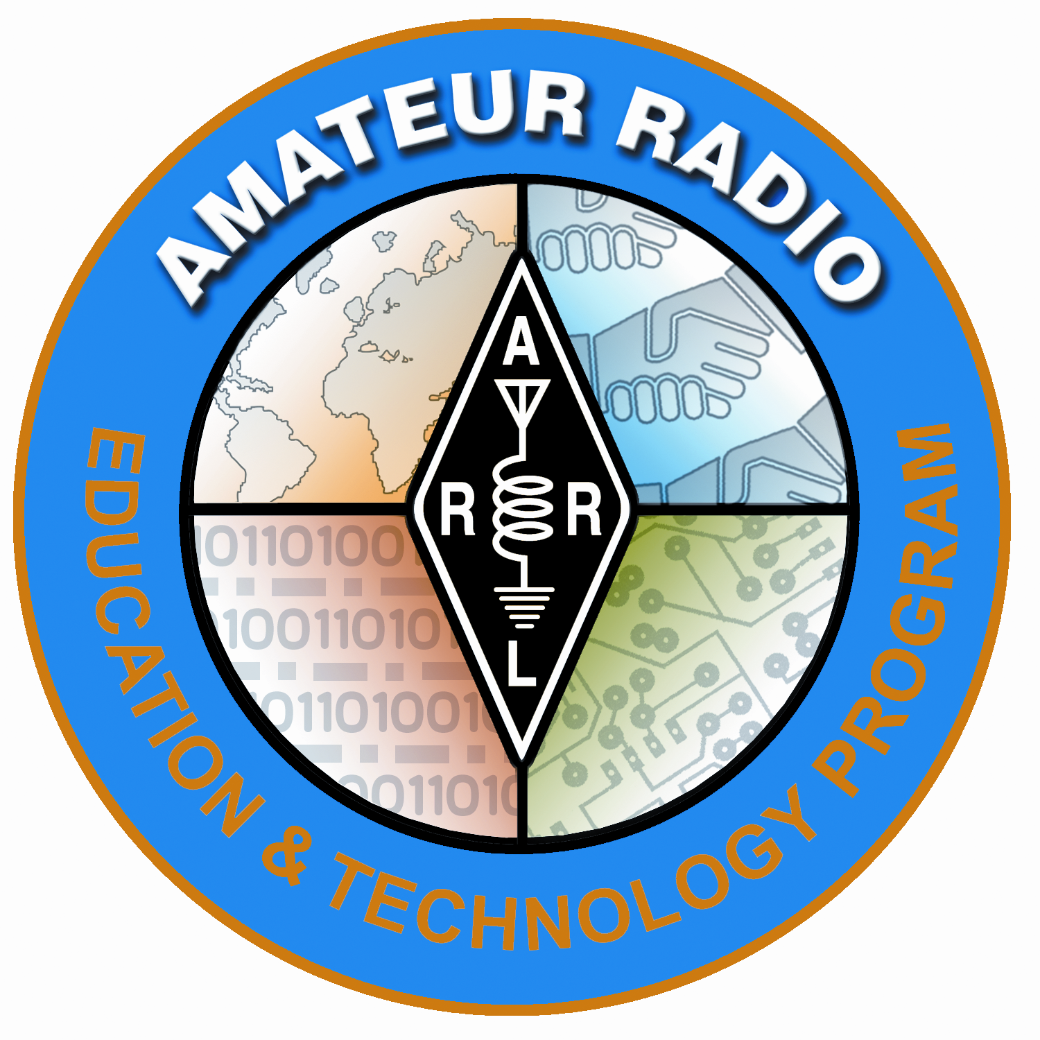
Lesson Plan Prepared for
ARRL Education & Technology Program
Author(s): Mark Spencer | Date: 2003, rev. 2012
Title of Lesson: Oscillators | Grade Level: 4 – 12

Core Components

Subject, Content Area or Topic:

Communications, Physics

National/State Standards: (Assign as needed based on your state standards)

Common Core Standards: (Assign as needed based on your state requirements)

http://www.corestandards.org/

Vocabulary: : (Teacher add as needed based on your curriculum and learning requirements)

Learning Objectives (What will the students learn and/or demonstrate?)

The objective of this activity is for the students explore oscillators.

Materials/Resources

- The 5 building blocks demonstration board or the circuit board of your choice
- Oscilloscope, propscope or scope of your choice
- Voltmeter
- Audio amplifier (optional)

Safety (if applicable) NA

Prerequisite Understanding:

- Observation
- Basic electricity
- Technical Writing (Grade level)

Review with the students the vocabulary needed to describe a waveform (wavelength, frequency, cycle, crests, trough, positive side, negative side, and amplitude).

Review with the students the two types of electric current (AC and DC) and the properties of each.

Process Components
Anticipatory Set:
(“The Hook” -- something to excite the student about the subject matter)

Securely tie a strong spring to a wall or ceiling. Attach a string to the spring. Pull the string back and let the spring. Have your students discuss what they just observed and how it might have a connection with electronics.

Instructional Input or Procedure (Input, modeling, and checking for understanding)

What to do and how to do it:

- Set up the oscilloscope and connect one channel of the scope to the DC voltage supply. Have the students record their observation of the waveform present and describe what the waveform display is telling them about the voltage being sampled.

- Connect the second channel of the scope to the output of the variable frequency oscillator (VFO). Have the students record their observations of the waveform present and describe what the waveform display is telling them about the peak voltage and the period in seconds.

- If connected, turn on the audio amplifier and have the students listen to and note the pitch of the oscillator for later comparison.

- Change the frequency of the VFO from the low to high end of the frequency range and repeat as often as needed. Have the students record their observations of the waveform presented and describe what the waveform display is telling them about the peak voltage and period in seconds.

- If connected, turn on the audio amplifier and have the students listen to and note the pitch of the VFO for later comparison.

Guided Practice

- Assign the students to create waveform drawings in their journals and label each component of the waveform with the data collected from their scope observations.

- Assign the students to calculate the frequency of the first two waveforms and compare their calculated values with the actual frequency of the preset oscillators.

Independent Practice

- Ask the students to describe in their journals the relationship they observed between frequency, wavelength, and pitch.

Assessment/Closure

Assessment (Pre, post etc…)

- What happens to the pitch (tone) that the wave produces as the wavelength gets shorter?

- What was the waveform of the electric current that supplied power to the oscillator? What was the shape of the waveform of the electric current of the output of the oscillator?

- When the wavelength of the last oscillator was changed, what happened to the amplitude of the wave? What happened to the period? What happened to the pitch?

- What is the relationship between frequency and pitch?

- What is the relationship between frequency and period?

- What is the relationship between wavelength and frequency?

- An oscillator converts what type of current into what other type of current?

- In normal every-day language, what does the term amplitude mean?

Enrichment:

Resources/References

Ham Radio License Manual Pg 10.17

ARRL Handbook Pages 9.18 – 9-33

Understanding Basic Electronics pages 4.5

http://www.arrl.org/files/file/ETP/The%205%20Building%20Blocks%20activity%20board%202_3.pdf

*Every lesson is different so you may not have to fill in all areas.

Notes:

Adaptations for special needs:

There may be substantial accommodations required for this activity depending of the need. Hearing impaired students will be able to detect amplitude and pitch changes by touching the amplifier speaker. Visually impaired students may need a tactile manipulative that simulates the sine wave form displayed on the oscilloscope. Tactile waveforms with various wavelengths prepared before the class period can be made out of corkboard with push pins and rubber bands or yarn. The push-pins are placed at points along the sine wave plot and the rubber bands or yarn are formed along the points of the plot.

