
Lesson Plan Prepared for
ARRL Education & Technology Program
Author(s): Nathan McCray | Date: 02/19/2013
Title of Lesson: Capacitors | Grade Level: 4 – 12

Core Components

Subject, Content Area or Topic:

Physics, Electronics, Science, Math

National/State Standards: (Assign as needed based on your state standards)

Common Core Standards: (Assign as needed based on your state requirements)

http://www.corestandards.org/

Vocabulary: (Teacher add as needed based on your curriculum and learning requirements)

Learning Objectives (What will the students learn and/or demonstrate?)

The objective of this activity is for the students to explore capacitors.

Materials/Resources

Experiment 1:
Comb(s)
Capacitors of various shapes and sizes
220 uF electrolytic capacitor
9V Battery
Resistor (teachers choice)
LED

Experiment 2:
volt-ohm meter or multimeter
Roll of aluminum foil
Several sheets of plain white paper
Scissors
Adhesive tape 9-volt battery
Two insulated jumper leads (alligator clips make this easier to do)

Safety (if applicable) NA
Review safety procedures when handling any capacitor. They can store a shock great enough to hurt or kill.

Prerequisite Understanding:
- Basic Electricity
- Current
- Ohm’s Law (It is critical that your students understand the formula!)

Process Components
Anticipatory Set:
(“The Hook” -- something to excite the student about the subject matter)
Ask:
What are some devices that hold energy?

Have a few students run a comb through their hair (Another good analogy is taking clothing out of a dryer.)

Ask: Why do you think the hair becomes charged? Is the comb charged?

Talk to your students about what is happening. Make sure they understand that apposing charges build up on the comb and hair. When the comb is brought into proximity to the hair, the hair is attached to the comb and stands on end. Most people understand what static discharge is and have experienced the unexpected spark when they touch another object. This phenomenon is basically how a capacitor works, by storing that charge.

Instructional Input or Procedure (Input, modeling, and checking for understanding)

When you conduct this lesson make sure you remind the students about the following:

The value of the capacitor is determined by 3 physical factors:

- The amount of surface area of the conductive plates. The larger the surface area, the more charge, and therefore the higher capacitance value.
- The distance between the plates. The closer the conductive plates are to each other, the stronger the electrostatic field that is developed. When the plates are close together, the attraction between the opposing poles is stronger. The closer the plates are together the higher the capacitance.
- The insulating material between the plates. Certain materials are more conducive to separating the poles than others; this allows capacitors to handle higher voltages or to hold a charge longer. Certain materials are very thermally stable and will not expand or contract as much with temperature changes therefore making the capacitance value more stable over wide operating temperatures.
  - Note: Drawings are available at end of document

Next:

Give the definition of a capacitor and talk about how the electrical charge is stored. You will then want to have your students work individually or in small groups to conduct the next experiment. You will model how a capacitor will work using a 220 uF capacitor, 9V battery, LED and resistor. Follow these steps:

- Take a lead from your resistor and wrap it around the long (positive +) lead of your LED.
- Charge your capacitor by placing the long (positive +) lead to the positive post of the battery and short (Negative -) lead the negative post on the battery. It will only take a few seconds for the capacitor to charge.
- Touch the positive lead of the capacitor to the resistor.
- Touch the negative lead of the capacitor to the negative lead of the LED
  - The LED will light up and slowly dim until the capacitor is fully discharged

Discuss how this process works. Ask:

- Does it work exactly like a battery? If not, what makes it different? What makes the analogy the same?

Guided Practice

Announce to the class that they will be making their own capacitors. The steps to do this are as follows:

- Cut two strips of aluminum foil 1” X 4’
- Cut two strips of paper 1½” X 4’ (Note: The insulator must be wider than the conductors)
- On a flat surface place one strip of aluminum foil
- Next, place a strip of paper on top of the foil you just laid down
- Place a strip of aluminum foil on the top of the paper strip (We are in a sense making a sandwich)

  - Position the top foil strip one inch over the piece of paper (Note: do not let the pieces of foil touch each other!).
- Lay the final strip of paper over top (You should now have four layers of material)

- Roll all four layers together starting at the end with the extra 1 inch of aluminum foil
  - Ensure you role them tightly as possible
- When your capacitor is formed, use tape to secure it
- Check to make sure we do not have a short circuit by placing the leads of your meter on the tow aluminum foils strips at the open end.
  - If your meter shows a “0” then your capacitor is ready. If you show a voltage, you have a short and will have to start again.
- Now, connect your jumper leads to the battery, one to the positive terminal and one to the negative terminal (Don’t let the wire leads touch each other)
- Touch on of the foil strips with the lead connected to the positive battery terminal and then touch the other foil strip with the lead coming from the negative battery terminal. This will charge your capacitor! Only make this connection for a second or two!
- You should now have a charge built up across the aluminum foil plates

To check to see if your capacitor works complete the following:

- Place the leads from a volt meter across the foil ends. Note the polarity!
- Place the positive (+) lead from your VOM to the positive foil strip that was attached to the positive side of the battery (You may want to mark the foil with a (+) or (-) so you remember which one was which)
- Place the negative (-) lead from your VOM to the negative foil strip that was attached to the negative side of the battery.
- You should record a voltage reading on your VOM. If you did, congratulations! Your capacitor works! If not, you may have to start all over again.

Independent Practice

Have each student or group build two or three more capacitors just like the one they made. Have them connect the new capacitors in parallel. They can do this by taping the one end of a capacitor to another.

Have them predict what kind of reading they will get after charging their capacitors in parallel.

Ask:

Do you think it will hold a charge longer? Why or why not?
Do you think this is more electricity stored? Why or why not?

Assessment/Closure

Assessment (Pre, post etc…)

- During these experiments we only used DC as a source of power. Once the capacitor reaches full charge (the forward voltage equals the reverse pressure), what happens to the current flow? (It ceases to flow, essentially blocking the current.)
- Why do you think you got the results of the capacitors in series? Explain.
- If we would have used an A/C source would there be a different result? Why or why not?

Enrichment: As teacher sees fit. See resources below. There are many ways to teach this.

Resources/References

http://www.arrl.org/files/file/ETP/Basic%20Electronics%20Course.pdf

ARRL Handbook Pages 2.5 – 2.6

Understanding Basic Electronics pages 9.1 – 9.26

http://www.youtube.com/watch?v=ZYH9dGl4gUE

http://www.wikihow.com/Build-a-Capacitor

http://www.absorblearning.com/electronics/demo/units/AEP_07.html

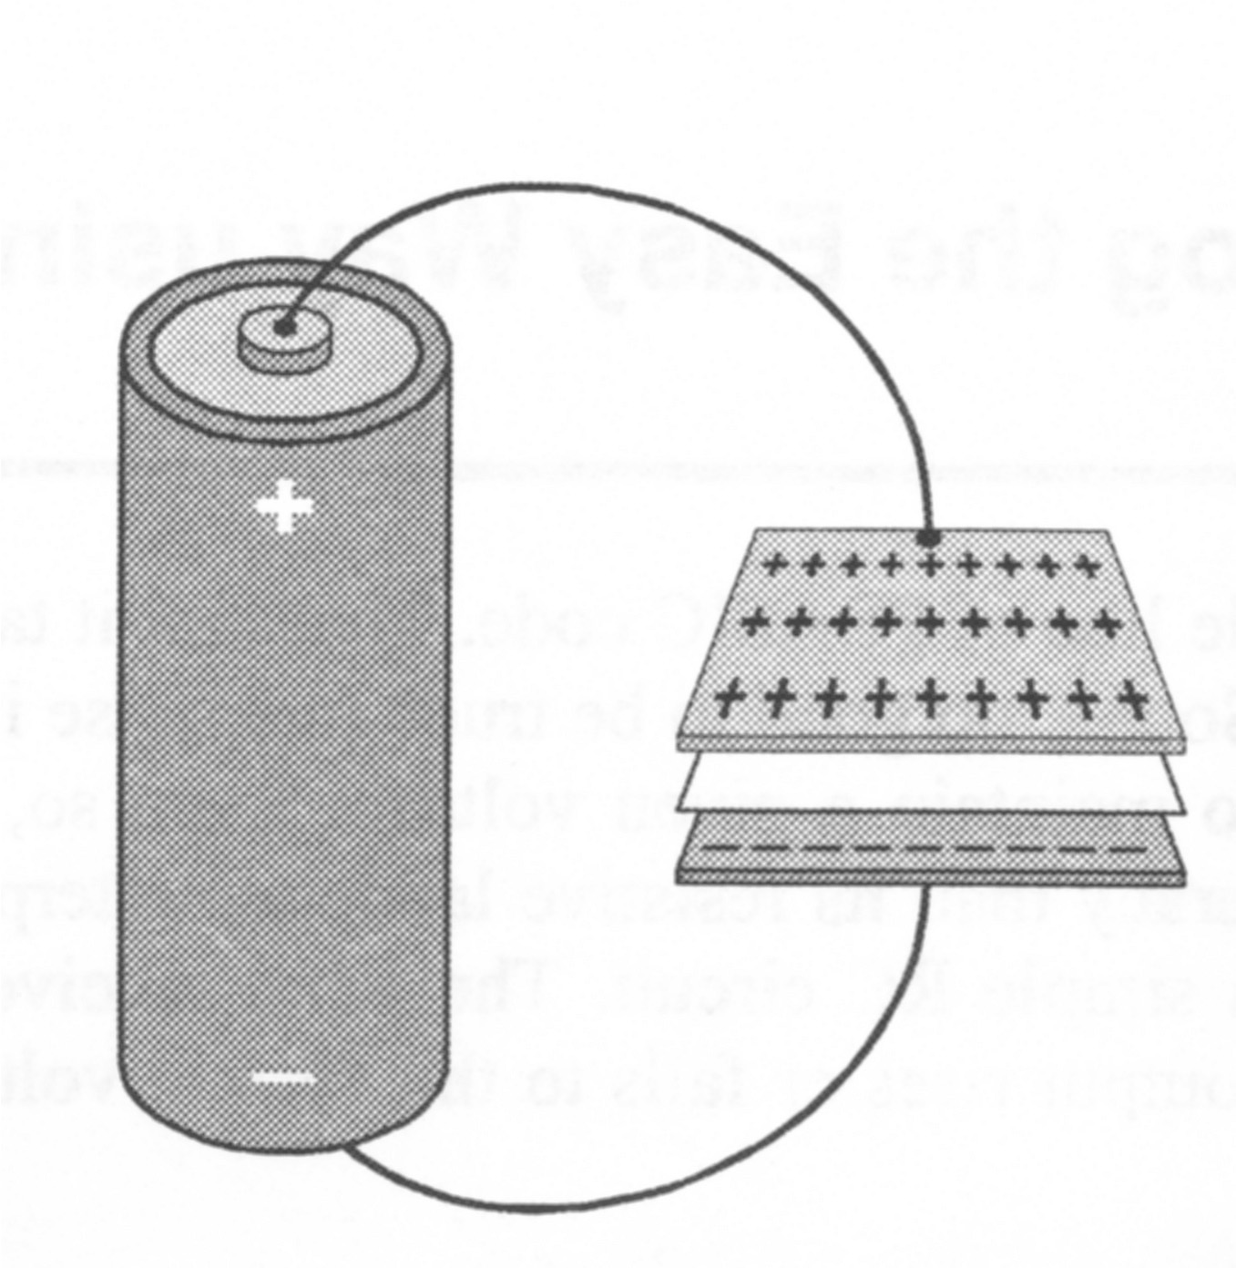

Water Tank Analogy

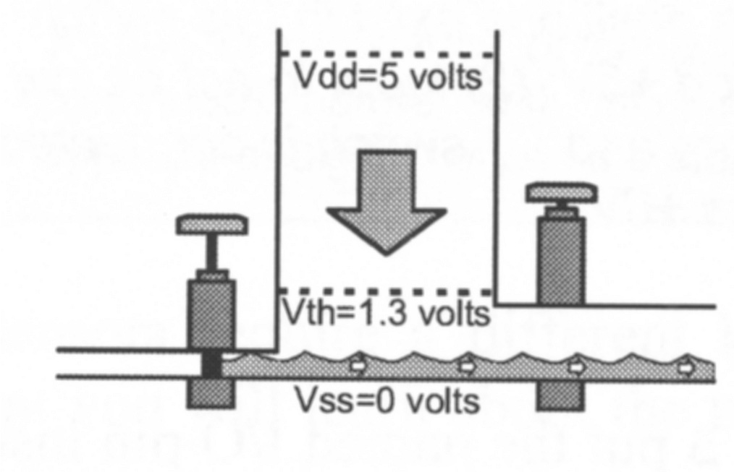
Discharging a Capacitor (Water Tank Analogy)

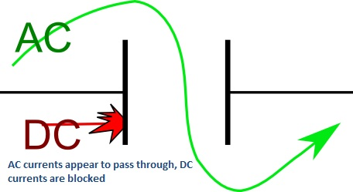

*Every lesson is different so you may not have to fill in all areas.

Notes:

